SCG.'

Department:

Higher Education and Training

# REPUBLIC OF SOUTH AFRICA

APRIL EXAMINATION

NATIONAL CERTIFICATE

# STRENGTH OF MATERIALS AND STRUCTURES N5

(8060065)

## 9 April 2014 (Y-Paper)

Requirements: 1. Hot rolled structural steel sections BOE8/2 Calculators may be used.

This question paper consists of 5 pages and 4 diagram sheets*

-2-

DEPARTMENT OF HßGHER EDUCATION AND TRAINING

REPUBLIC OF SOUTH AFRICA

NATIONAL CERTIFICATE

STRENGTH OF MATERIALS AND STRUCTURES N5

TIME: 3 HOURS

MARKS: 100

INSTRUCTIONS AND INFORMATION Answer ALL the questions.

Read ALL the questions carefully.

Number the answers according to the numbering system used in this question paper.

Write neatly and legibly,

Copyright reserved

-3-

The following results were recorded during a tensile test on a mild-steel specimen:

|  |  |  |
| --- | --- | --- |
| Diameter of test piece |  |  |
| Gauge length | 56,3 mm |  |
| Load at yield point | 20,5 kN |  |
| MaxiiTiurn load | 48,6 kN |  |
| Distance between gauge marks after fracture | 72,9 mm |  |
| Minimum diameter of fractured test piece  Calculate the following:  Tensile strength  Yield stress  Percentage elongation  Percentage reduction in area  QUESTION 2 | 7,98 mm |  |
| The stepped bar shown in FIGURE 1 DIAGRAM SHEET 1 (attached) is fixed securely to a rigid support at its upper enq and has a rigid collar at its lower end. Through what height can a load of kN be allowed to fall if the maximum permissible stress in the bar is 64 MPa.AFÖ,öd42 m?and AF 0,0026 m 2? | |
| E = 200 GPa.  QUESTION 3  A column NIC) m longis formed by lacing four 120 mmx 120 mm x 10 mm angles as shown in FIGURE 2 DIAGRAM SHEET 2 (attached) to form a square cross-section. Using,Rankine formulae for pinned ends, determine the safe axial load for the column. Take the yield stress as 245 MPa, the factor of safety as 5 and a — 1 The | | [13] |
| contribUtjon of the lacing bars to the strength of the column may be disregarded. | | [12] |

### QUESTION 4

A rectangular strip of aluminium 50 mm wide and 15 mm thick is clad on both the 50 mm sides by brass strips 5 mm thick (parallel coupling). The three strips are bonded together so that under all conditions they have the same length.

At 40 o c the length of the composite bar is 630 mm. The temperature of the composite bar is then raised to 1 10 Q C, Eal = 80 GPa; = 22x10-6/0c; Ebrass — 108 GPa and 5<10 6/0 c.

Calculate the following:

The stresses set up in the two metals

The final length of the composite bar

[12]

|  |  |
| --- | --- |
| QUESTION 5  A symmetrical built-up beam of I-sectional profile is as shown in FIGURE 3 DIAGRAM SHEET 3(attached).  Calculate the following: |  |
| 5.1 The position ot the neutral axis | (5) |
| 52 The second moment of area of the section about the neutral axis (Ixx) | (7) |
| 5.3 The least section modulus about the neutral axis (Zxx)  5.4 The mä*jmum span which can be used if the beam is to be simply supported to carry a uniformly distributed load of 5,6 kN/m and the maximum permissible | (2) |
| stress is 60 MPa. | (5) |

[19]

-5-

"FRT!ON 6

A shaft is to be used with a marine engine delivering 1 300 kW at 1 18 rpm. The maximum allowable shear stress for the shaft material is 56 MPa and the maximum torque to be transmitted by the shaft is 34% more than the mean torque. G = 80 GPa.

Calculate the following:

6.1 The internal and external diameters for a diameter ratio of 2 : 1

6.2 The twist in the shaft over a length of 2,5 m in degrees when transmitting the maximum torque

### QUESTION 7

Graphically determine the magnitude and nature of forces in the pin-jointed framework shown in FIGURE 4 DIAGRAM SHEET 1 (attached).

### QUESTION 8

A boiler drum must withstand an internal, pressure of 2,6 MPa and has a wall thickness of 20 mm. The drum is riveted along its length as well as around the circumference. The joint efficiencies of the longitudinal and circumferential joints are 82% and 44% respectively. The allowable Stress in the material must not exceed 120 MPa. Calculate the allowable internal diameter of the boiler drum.

TOTAL: 100

FIGURE 1





400 mm



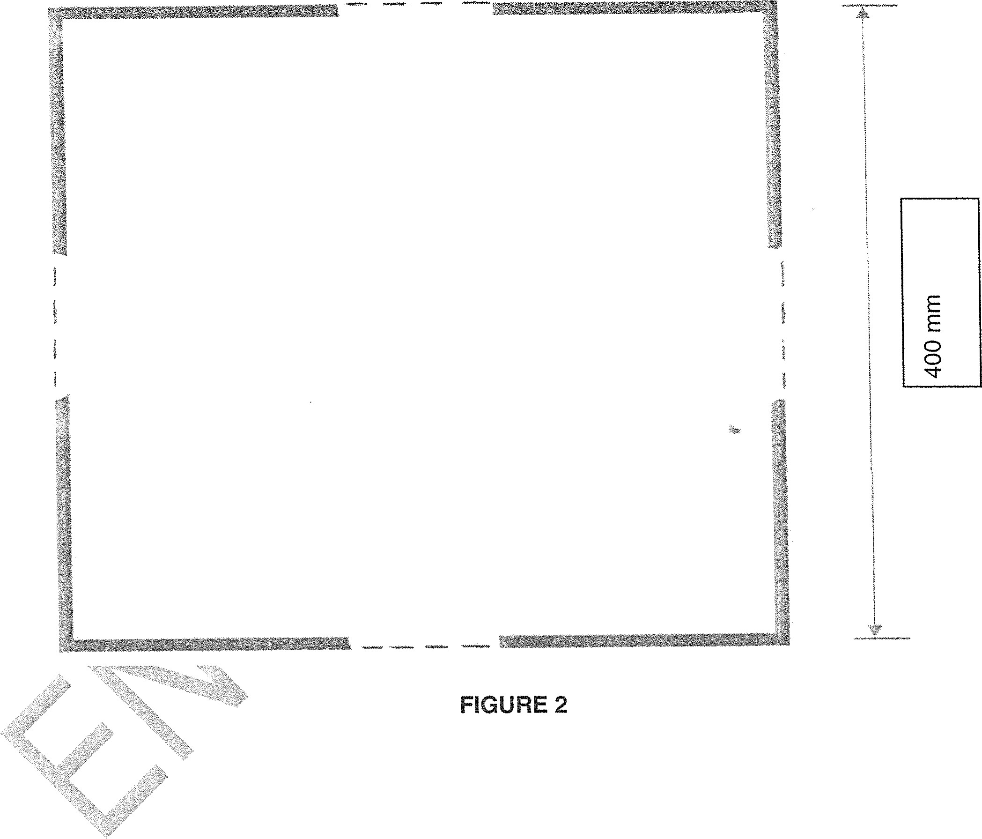





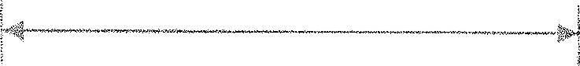

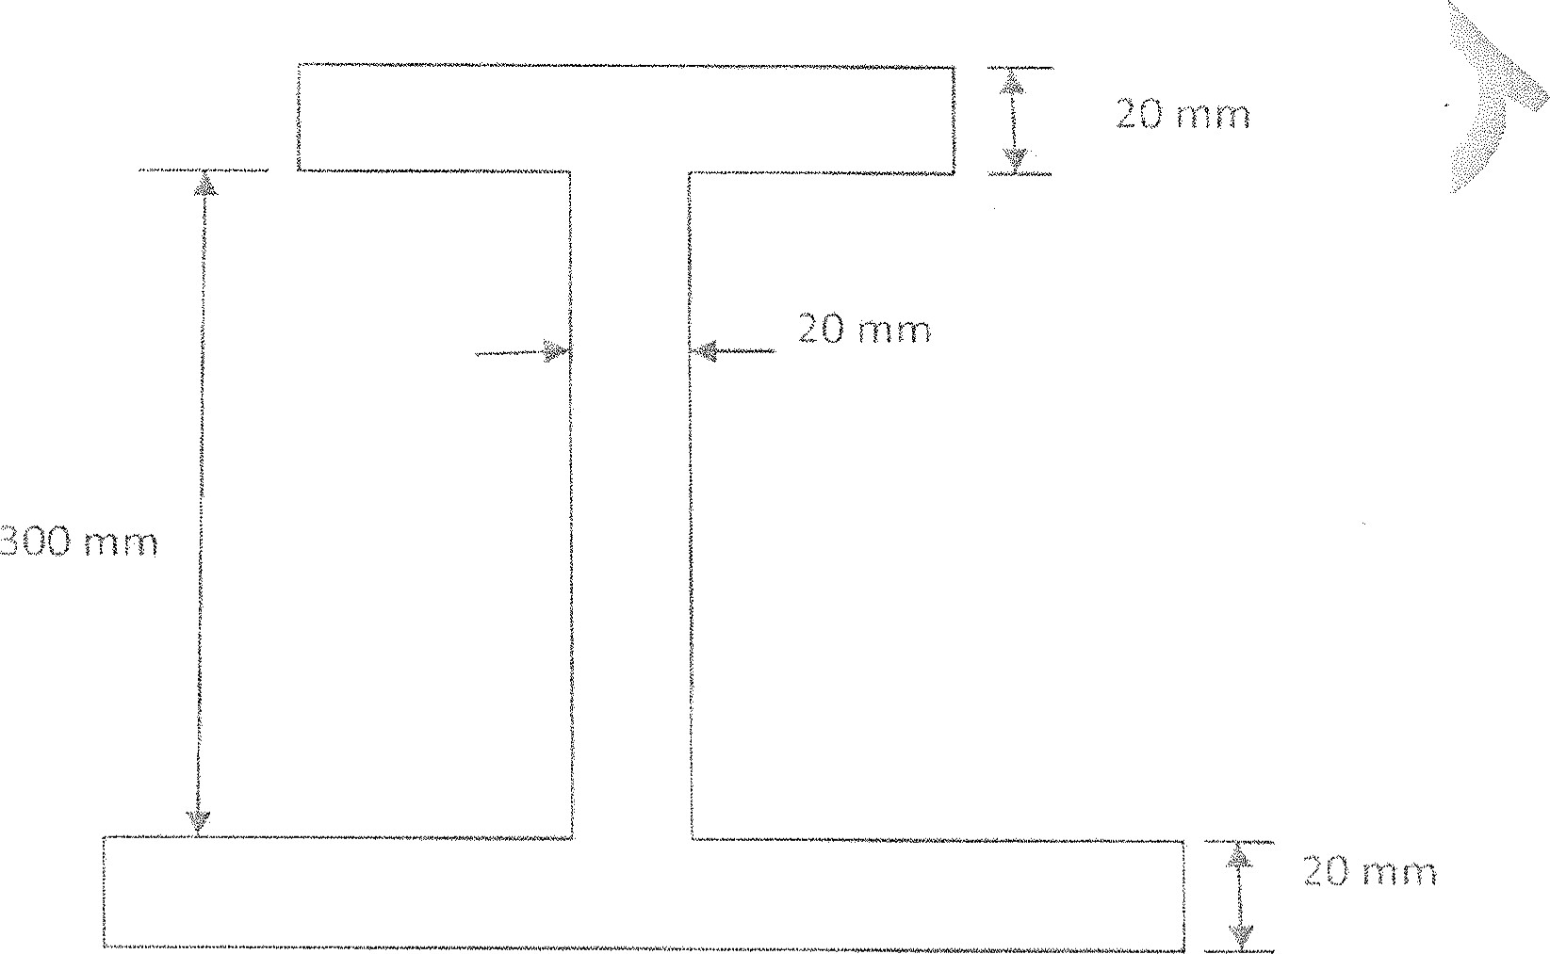

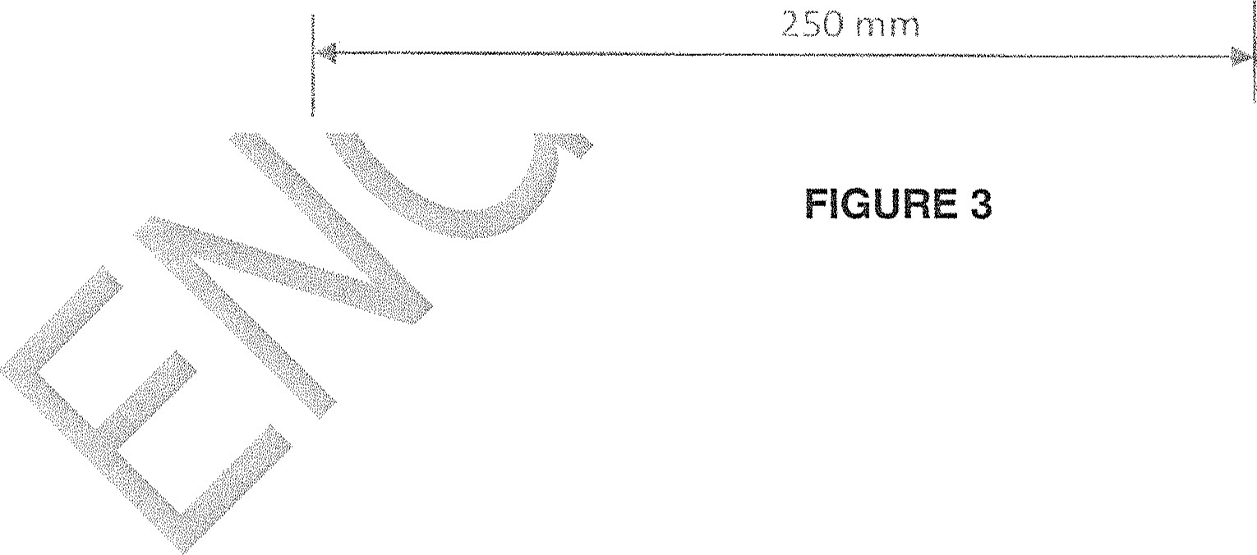

-4-

4 kN

20 m

FIGURE 4